
CS 255 Business Requirements Document

System Components and Design

Purpose
What is the purpose of this project? Who is the client and what do they want their system to be able to do?
- The purpose of this project is to design a centralized, cloud-based system for DriverPass that supports driver education and training services.
- DriverPass is a company focused on improving DMV test pass rates by offering online practice exams, instructional content, and optional in-person driving lessons.
- The system is intended to provide students with a structured, accessible way to prepare for driving exams while allowing DriverPass staff to manage scheduling, training resources, and customer information.
- The system must support multiple user roles, ensure secure access, and provide accurate tracking of student progress and lesson activity.

System Background
What does DriverPass want the system to do? What is the problem they want to fix? What are the different components needed for this system?
- DriverPass identified a widespread issue where many students fail DMV driving tests due to insufficient preparation and lack of accessible training resources.
- To address this problem, DriverPass plans to offer a combination of online learning tools and in-person driving instruction through a single integrated system.
- The system will be web-based and cloud-hosted, allowing access from any internet-connected device without requiring local installation or maintenance.
- Core system components include user account management, lesson scheduling, online testing, progress tracking, role-based access control, and administrative reporting.
- The system is designed to reduce operational complexity for DriverPass while improving the learning experience for students.

Objectives and Goals
What should this system be able to do when it is completed? What measurable tasks need to be included in the system design to achieve this?
- Provide students with the ability to create accounts, schedule driving lessons, and access online practice exams.
- Allow students to track their progress, view test results, and monitor lesson completion status.
- Enable staff members to manage student information, lesson schedules, drivers, and vehicles efficiently.
- Ensure administrators can oversee system activity, manage user roles, and generate reports for accountability.
- Maintain current and accurate training content aligned with DMV requirements.
- Deliver a reliable, secure, and scalable system that supports DriverPass’s business operations and future growth.

Requirements

Nonfunctional Requirements
In this section, you will detail the different nonfunctional requirements for the DriverPass system. You will need to think about the different things that the system needs to function properly.

Performance Requirements
What environments (web-based, application, etc.) does this system need to run in? How fast should the system run? How often should the system be updated?
- The DriverPass system must support concurrent access from students, instructors, and administrative staff without noticeable performance degradation. Page loads and scheduling actions should complete within two seconds under normal operating conditions. The system should maintain availability of at least 99 percent, excluding scheduled maintenance windows. The system shall process scheduling updates and lesson confirmations in real time.

Platform Constraints
What platforms (Windows, Unix, etc.) should the system run on? Does the back end require any tools, such as a database, to support this application?
- The system shall operate as a web-based application accessible through modern desktop and mobile web browsers. The system shall not require the installation of specialized software or hardware. The system shall integrate with approved third-party services for payment processing and practice exam content, which may impose external operational constraints.

Accuracy and Precision
How will you distinguish between different users? Is the input case-sensitive? When should the system inform the admin of a problem?
- The system must accurately record student progress, lesson completion status, and payment transactions. Scheduling data must reflect real-time instructor availability to prevent double-booking or conflicts. All stored user information, including lesson history and purchase records, must be consistently maintained across system sessions.

Adaptability
Can you make changes to the user (add/remove/modify) without changing code? How will the system adapt to platform updates? What type of access does the IT admin need?
- The DriverPass system should be designed to allow updates to practice exam content, pricing structures, and scheduling rules without requiring major system redesign. The system should support future expansion, such as additional locations, instructors, or training services, with minimal disruption to existing users.

Security
What is required for the user to log in? How can you secure the connection or the data exchange between the client and the server? What should happen to the account if there is a “brute force” hacking attempt? What happens if the user forgets their password?
- The system shall enforce secure user authentication using encrypted credentials and role-based access control. The system shall restrict administrative functions to authorized users only. Payment information shall be processed through secure third-party providers and shall not be stored directly within the system. The system shall log administrative actions and retain audit records for a minimum of one year.

User Interface Requirements
- The DriverPass system will provide a role-based user interface tailored to the needs of each type of user. The interface will be web based and designed for ease of use, clear navigation, and consistency across all user roles.

Student Interface
- Students will have access to a personal dashboard that allows them to register for an account, log in securely, view and purchase lesson packages, schedule driving lessons, take online practice exams, and review test results. Students will also be able to view upcoming lessons, receive notifications, and track their progress over time.

Instructor Interface
- Instructors will have access to a dashboard that allows them to view assigned students, manage lesson schedules, update availability, and record lesson notes. Instructors will also be able to view student progress and submit feedback after each driving session.

Secretary Interface
- The secretary interface will support administrative scheduling tasks, including managing lesson bookings, resolving scheduling conflicts, and assisting with customer inquiries. The secretary will also be able to view student and instructor schedules and update lesson assignments as needed.

Management Interface
- Management users will have access to reporting and oversight features, including viewing system usage, lesson package sales, student performance trends, and instructor activity. Management will also be able to manage lesson packages and pricing.
- IT Administrator Interface
- IT administrators will have access to system configuration tools, user account management, security settings, and system maintenance functions. This includes managing permissions, monitoring system health, and performing updates when required.
- The user interface will provide clear error messages, consistent navigation menus, and intuitive workflows to ensure a positive user experience for all roles.

Functional Requirements
Using the information from the scenario, think about the different functions the system needs to provide. Each of your bullets should start with “The system shall . . .” For example, one functional requirement might be, “The system shall validate user credentials when logging in.”
- The system shall allow students to create and manage personal accounts that include contact information, login credentials, and progress tracking.
- The system shall allow students to purchase practice exam packages and schedule behind-the-wheel lessons based on instructor availability.
- The system shall prevent scheduling conflicts by restricting overlapping lesson reservations for students, instructors, vehicles, or time slots.

- The system shall allow instructors to view assigned lessons, record lesson completion, and enter notes for each driving session.
- The system shall allow a secretary to schedule, reschedule, and cancel driving lessons on behalf of students.
- The system shall allow the secretary to manage instructor availability and resolve scheduling conflicts.
- The system shall allow students to view their scheduled lessons, completed lessons, and remaining required training.
- The system shall track lesson completion status for each student and update their progress history.
- The system shall generate management reports related to student progress, instructor workload, lesson utilization, and revenue.
- The system shall allow IT administrators to manage user roles, system access, and configuration settings.
- The system shall maintain audit logs for lesson scheduling changes, cancellations, and account updates, including timestamps and user identification.
- The system shall allow administrators to update practice test content when DMV requirements change.

Assumptions
What things were not specifically addressed in your design above? What assumptions are you making in your design about the users or the technology they have?
- Users will have access to a stable internet connection.
- Users will access the system using supported devices and browsers.
- Third-party services used by the system will remain available
- It is assumed that third-party services used for payments and practice exams will remain available and supported.

Limitations
- The system depends on third-party services that are outside DriverPass’s direct control.
- The system will not integrate directly with government or DMV databases.
- System performance may vary based on user device and network conditions.
- The system does not directly interface with DMV systems and relies on externally provided practice content.
- System functionality may be limited during outages of third-party service providers.

Gantt Chart
Please include a screenshot of the GANTT chart that you created with Lucidchart. Be sure to check that it meets the plan described by the characters in the interview.

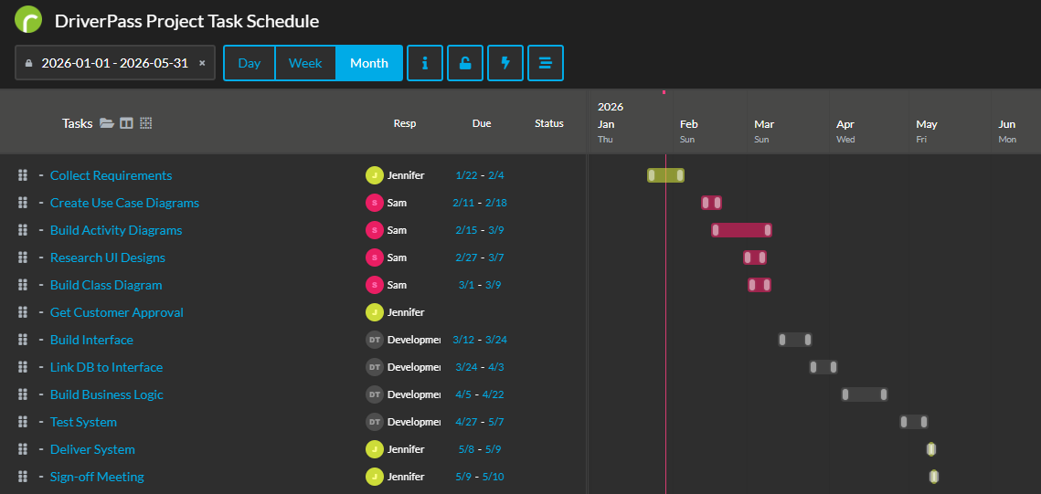

Schedule Milestones and Dependencies
- The Gantt chart follows a phased project structure where each group of tasks builds on the completion of the previous phase. Requirements gathering and system modeling are completed first, as these tasks define the scope and design needed before development can begin. Once modeling is approved, interface development, database integration, and business logic implementation proceed in sequence. Testing activities depend on the completion of development tasks to ensure the system functions as intended before delivery. The final milestones include system delivery and a formal sign off meeting, which confirm that all requirements have been met and approved by stakeholders.

